**5. ReactJS-HOL**

**Output:**

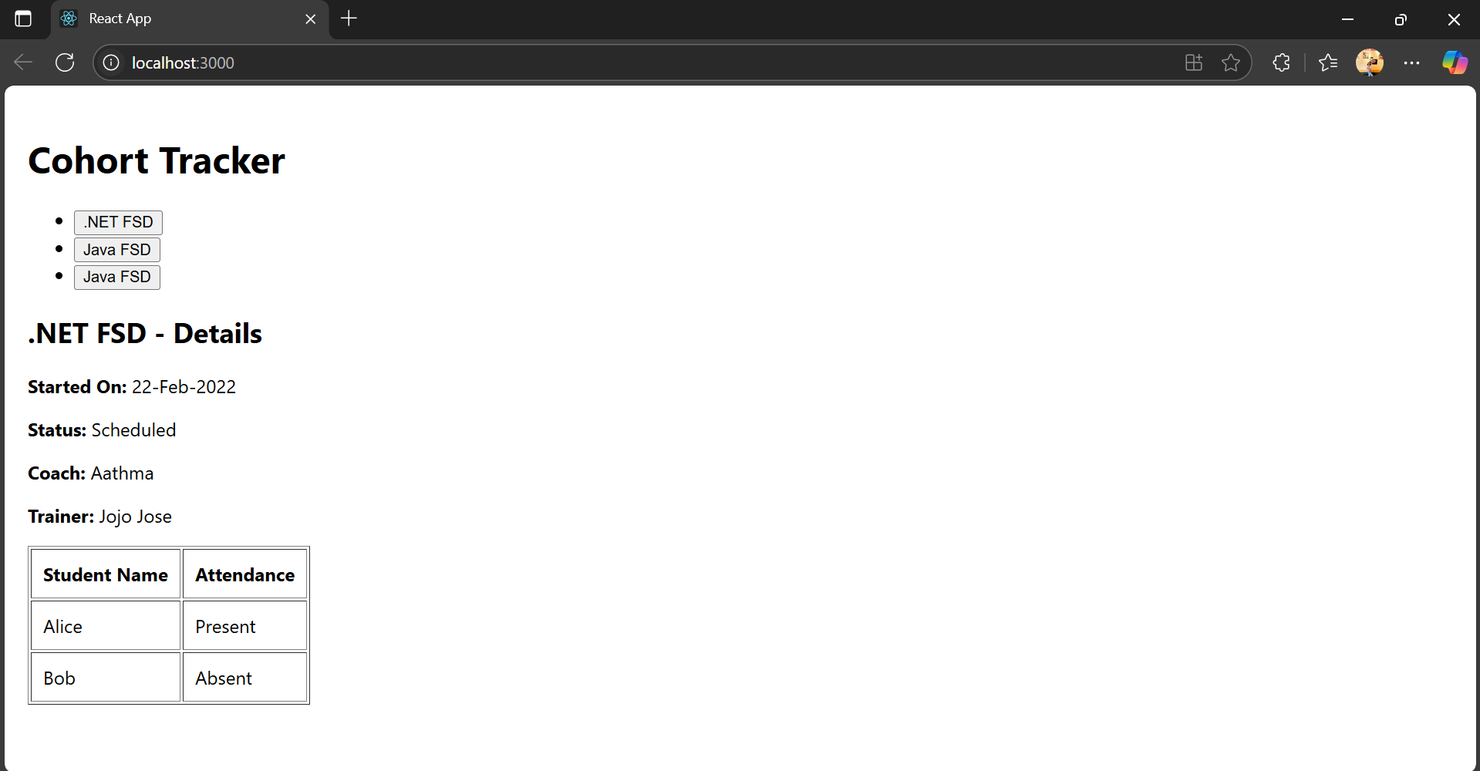

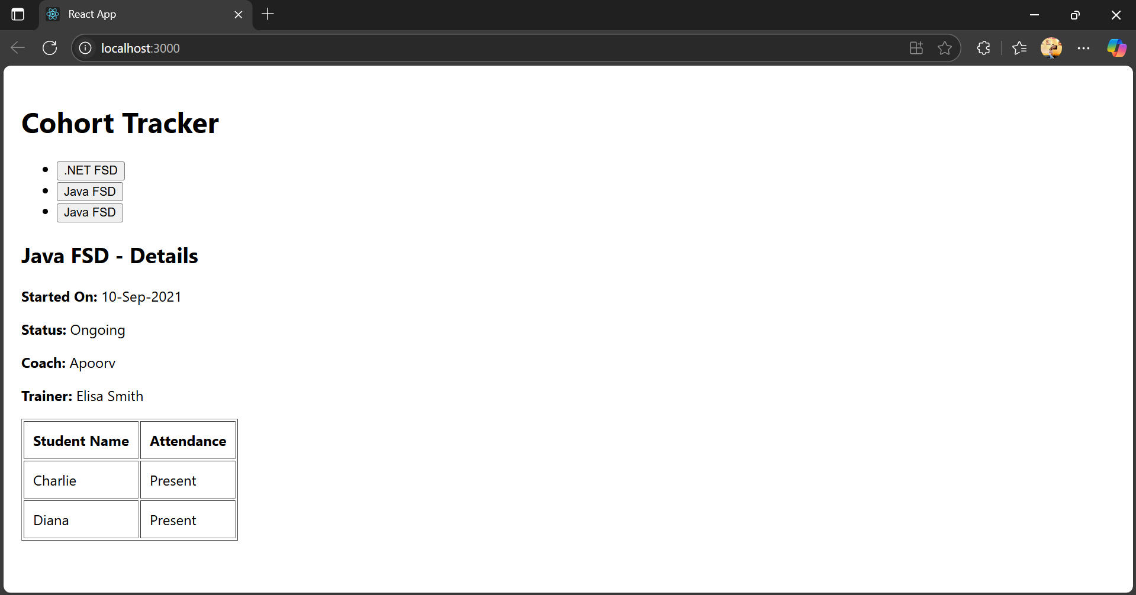

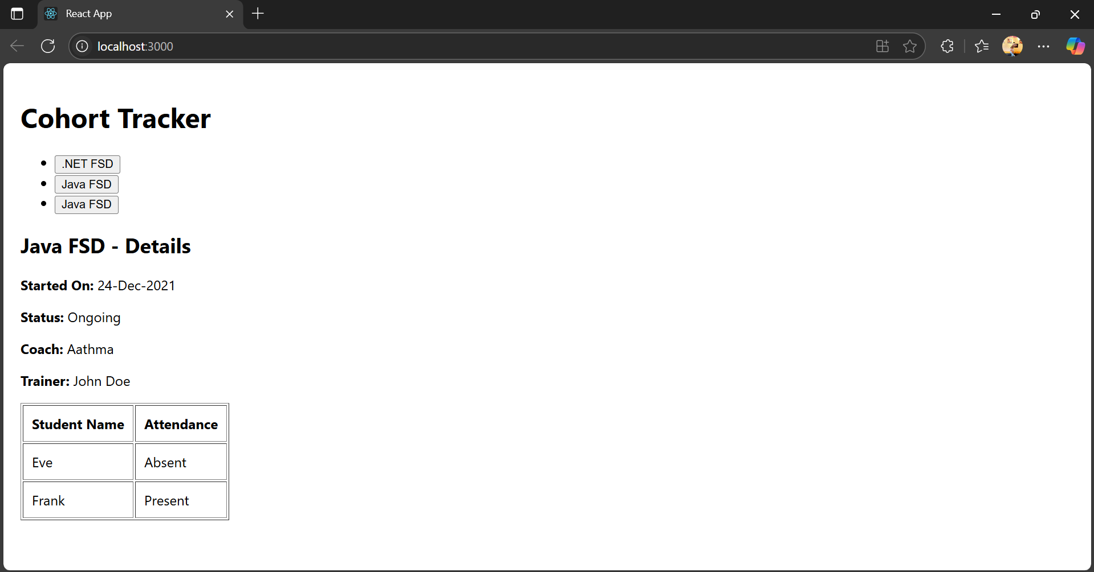

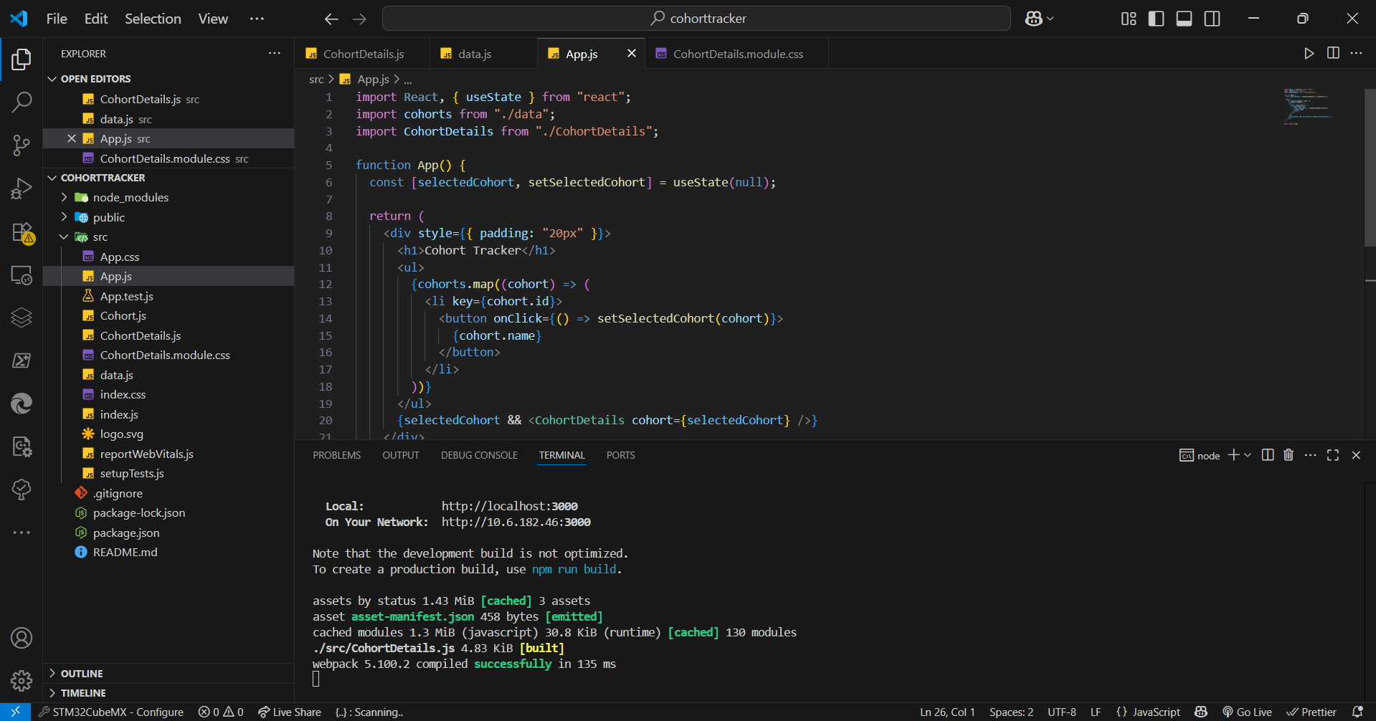

**App.js**

**import React, { useState } from "react";**

**import cohorts from "./data";**

**import CohortDetails from "./CohortDetails";**

**function App() {**

**const [selectedCohort, setSelectedCohort] = useState(null);**

**return (**

**<div style={{ padding: "20px" }}>**

**<h1>Cohort Tracker</h1>**

**<ul>**

**{cohorts.map((cohort) => (**

**<li key={cohort.id}>**

**<button onClick={() => setSelectedCohort(cohort)}>**

**{cohort.name}**

**</button>**

**</li>**

**))}**

**</ul>**

**{selectedCohort && <CohortDetails cohort={selectedCohort} />}**

**</div>**

**);**

**}**

**export default App;**

**CohortDetails.js**

import React from "react";

import "./CohortDetails.module.css";

const CohortDetails = ({ cohort }) => {

return (

<div style={{ marginTop: "20px" }}>

<h2>{cohort.name} - Details</h2>

<p>

<strong>Started On:</strong> {cohort.startedOn}

</p>

<p>

<strong>Status:</strong> {cohort.status}

</p>

<p>

<strong>Coach:</strong> {cohort.coach}

</p>

<p>

<strong>Trainer:</strong> {cohort.trainer}

</p>

<table border="1" cellPadding="10">

<thead>

<tr>

<th>Student Name</th>

<th>Attendance</th>

</tr>

</thead>

<tbody>

{cohort.students.map((student, index) => (

<tr key={index}>

<td>{student.name}</td>

<td>{student.attendance}</td>

</tr>

))}

</tbody>

</table>

</div>

);

};

export default CohortDetails;

**data.js**

const cohorts = [

{

id: "INTADMDF10",

name: ".NET FSD",

startedOn: "22-Feb-2022",

status: "Scheduled",

coach: "Aathma",

trainer: "Jojo Jose",

students: [

{ name: "Alice", attendance: "Present" },

{ name: "Bob", attendance: "Absent" },

],

},

{

id: "ADM21JF014",

name: "Java FSD",

startedOn: "10-Sep-2021",

status: "Ongoing",

coach: "Apoorv",

trainer: "Elisa Smith",

students: [

{ name: "Charlie", attendance: "Present" },

{ name: "Diana", attendance: "Present" },

],

},

{

id: "CDBJF21025",

name: "Java FSD",

startedOn: "24-Dec-2021",

status: "Ongoing",

coach: "Aathma",

trainer: "John Doe",

students: [

{ name: "Eve", attendance: "Absent" },

{ name: "Frank", attendance: "Present" },

],

},

];

export default cohorts;

**CohortDetails.module.css**

.box {

width: 300px;

display: inline-block;

margin: 10px;

padding: 10px 20px;

border: 1px solid black;

border-radius: 10px;

}

dt {

font-weight: 500;

}